V-Electronics: Revolutionizing Smart Device Management

**Phase 6: User Interface Development**

In this phase, focus shifted from backend automation and coding to building an intuitive, user-friendly interface. V-Electronics required a Salesforce interface that could accommodate sales agents, managers, and administrators while ensuring ease of use and accessibility. Salesforce Lightning Experience provided modern UI tools to create custom pages, layouts, and components.

**1. Introduction**

A clean and intuitive user interface enhances user adoption, reduces training costs, and increases efficiency. This phase leveraged Salesforce’s **Lightning App Builder**, **Lightning Pages**, and **Lightning Web Components (LWC)** to deliver a dynamic front-end experience.

**2. Objectives**

* To create tailored experiences for different roles (agents, managers, admins).
* To build custom record and home pages with essential tools.
* To use **Lightning Web Components** for flexibility and reusability.
* To connect LWC with Apex classes for dynamic, real-time data.

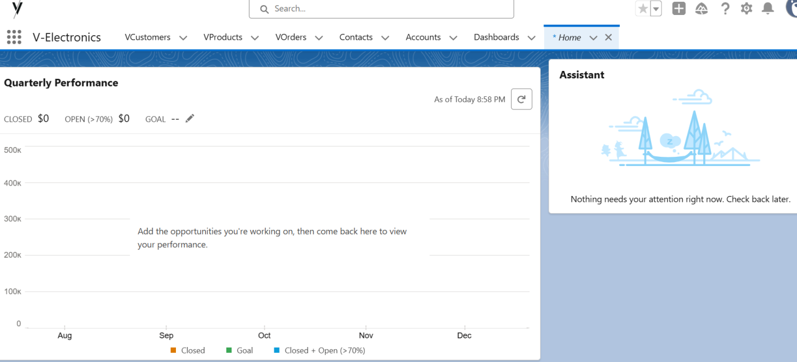

**3. Detailed Description of Contents**

**Lightning App Builder**

* Designed custom apps for Sales and Service users.
* Created **app-specific pages** including dashboards, reports, and utility tools.

**Record Pages**

* Customized record pages for **VCustomers**, **VOrders**, and **VProducts**.
* Added components like related lists, charts, and quick actions.

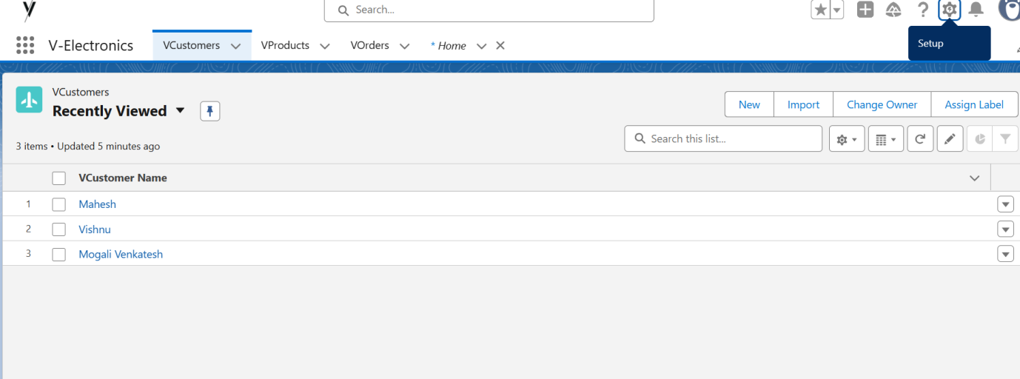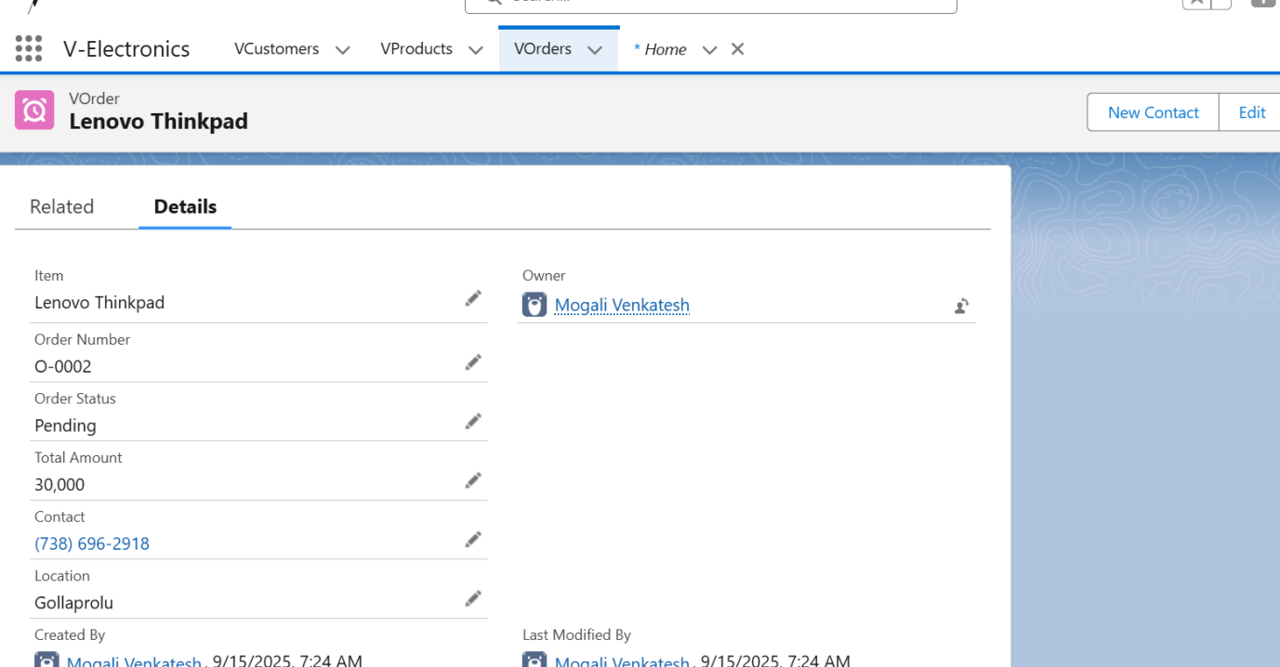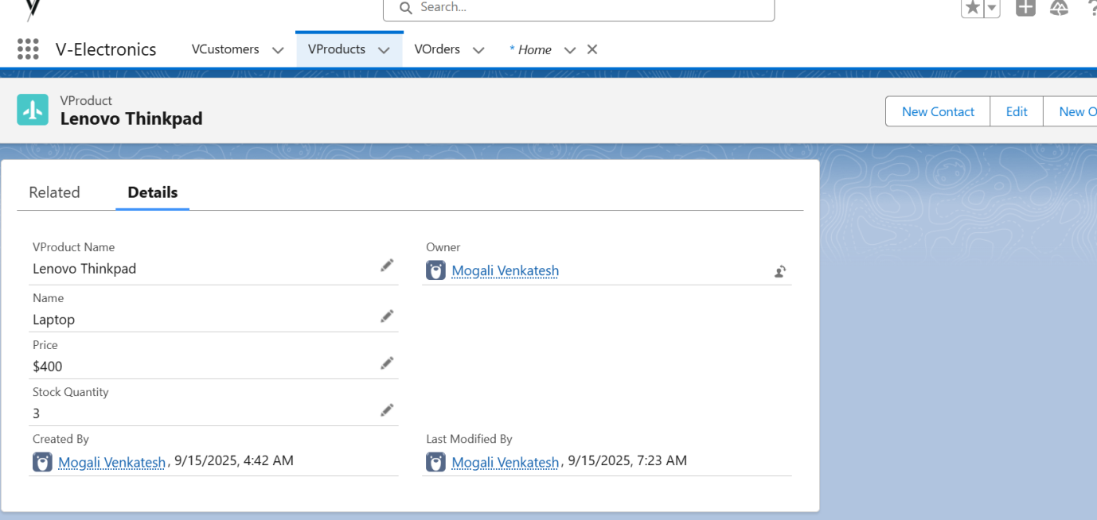

**Tabs & Home Page Layouts**

* Configured navigation tabs for easy access to frequently used objects.
* Personalized **Home Page Layouts** for Sales Reps (showing tasks, leads, and KPIs).

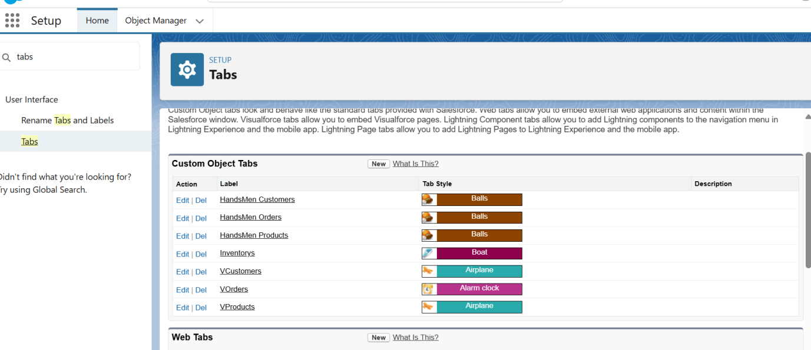

**Utility Bar**

* Added utility items such as **Notes**, **Open Cases**, and **Quick Order Entry**.

**4. Deliverables**

* Customized Lightning Apps, Home Pages, and Record Pages.
* Utility Bar for quick access tools.
* Multiple LWCs integrated with Apex for real-time data.

**5. Conclusion**

Phase 6 ensured users had a **seamless, interactive, and modern interface** to work with Salesforce. Backend logic (Phase 5) and declarative automation (Phase 4) were now fully accessible via an intuitive UI.